1. How many types of conditions are available in conditional formatting on Excel?

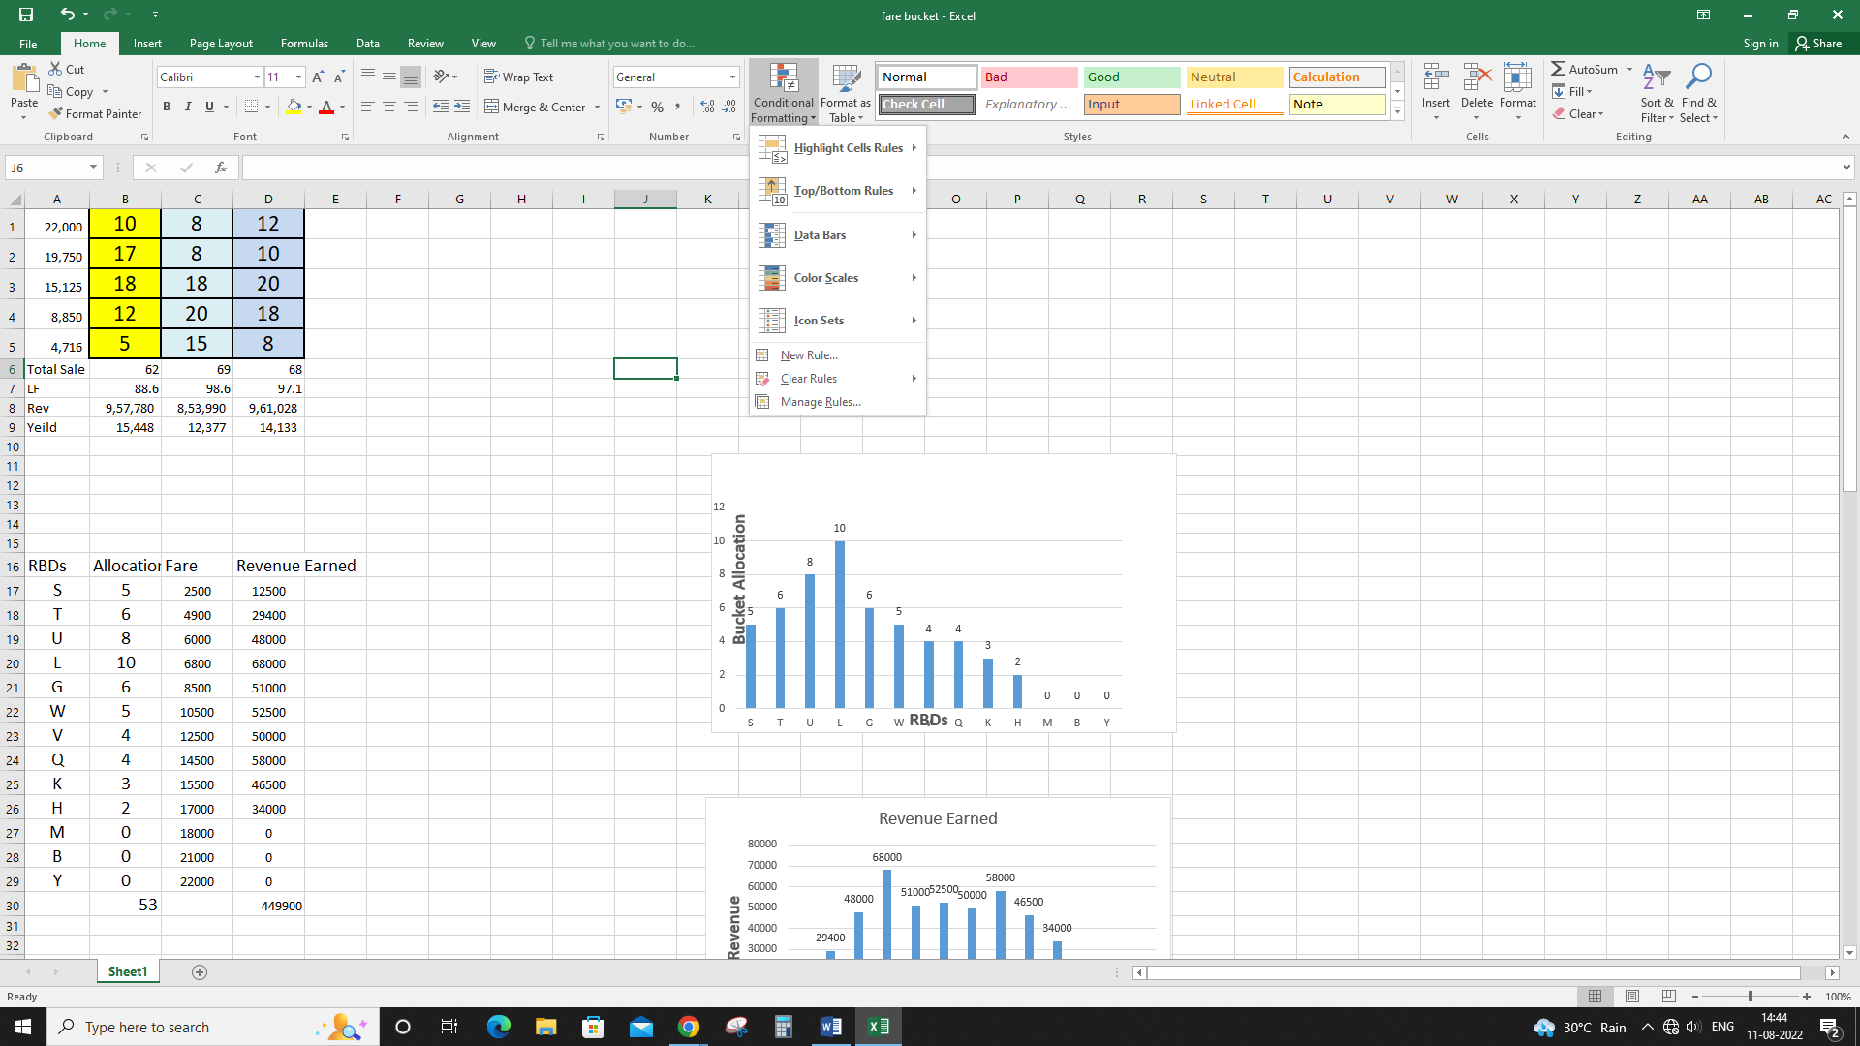Ans: Basically 6 types of conditional formatting are available.

These are:

1. Highlight Cell Rules
2. Top/Bottom Rules
3. Data Bars
4. Color Scales
5. Icon Sets
6. How to insert border in Excel with Format Cells dialog?

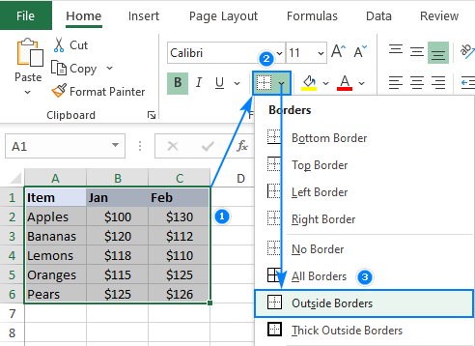Ans: The process is mentioned below:

1. Select a cell or a range of cells to which you want to add borders.
2. On the Home tab, in the Font group, click the down arrow next to the Borders button, and you will see a list of the most popular border types.
3. Click the border you want to apply, and it will be immediately added to the selected cells.

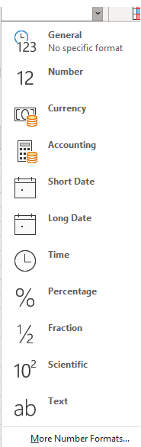

1. How to Format Numbers as Currency in Excel?

Ans: The process is mentioned below:

1. Select the cells that you want to format and then, in the **Number group** on the **Home tab**, click the down arrow in the Number Format box.
2. Choose either **Currency** or **Accounting**.
3. 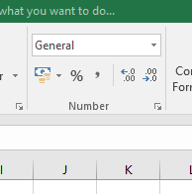What are the steps to format numbers in Excel with the Percent style?

Ans: To quickly apply percentage formatting to selected cells, click **Percent Style** Button image in the **Number** group on the **Home** tab, or press **Ctrl+Shift+%**. If you want more control over the format, or you want to change other aspects of formatting for your selection, you can follow these steps.

1. 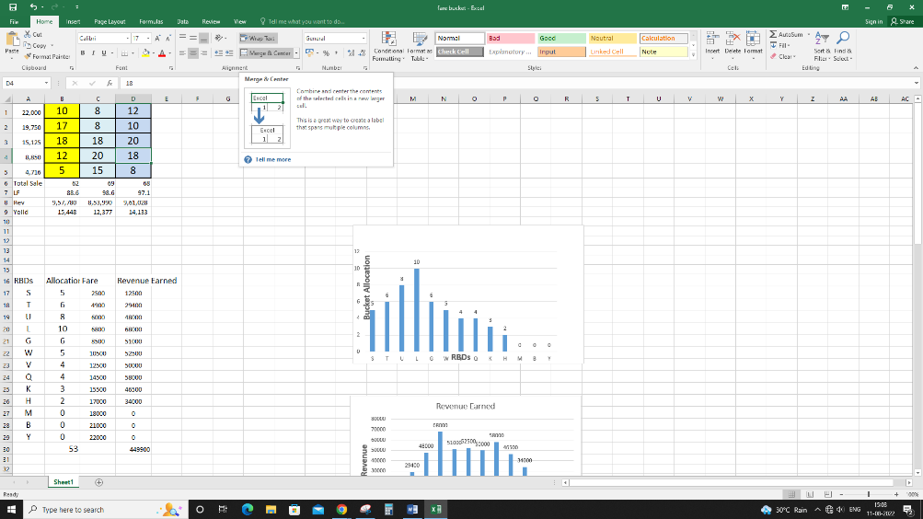What is a shortcut to merge two or more cells in excel?

Ans: The process is:

1. Select the cells to merge.
2. Select Merge & Center.
3. How do you use text commands in Excel?

Ans: To use text commands in Excel, the formula is

**=TEXT(Value you want to format, "Format code you want to apply")**

Example: =TEXT(TODAY(),"MM/DD/YY") is for Today’s date in MM/DD/YY format, like 03/14/12